## 第六章

P234_2

#include <iostream>

using namespace std;

class student

{

private:

char name[20];

unsigned int id;

double score;

public:

void input();

void output();

};

void student::input()

{

cout<<"name? ";

cin>>name;

cout<<endl;

cout<<"id? ";

cin>>id;

cout<<endl;

cout<<"score? ";

cin>>score;

}

void student::output()

{

cout<<"name:"<<name<<"\tid:"<<id<<"\tscore"<<score<<endl;

}

int main()

{

student S;

S.input();

S.output();

}

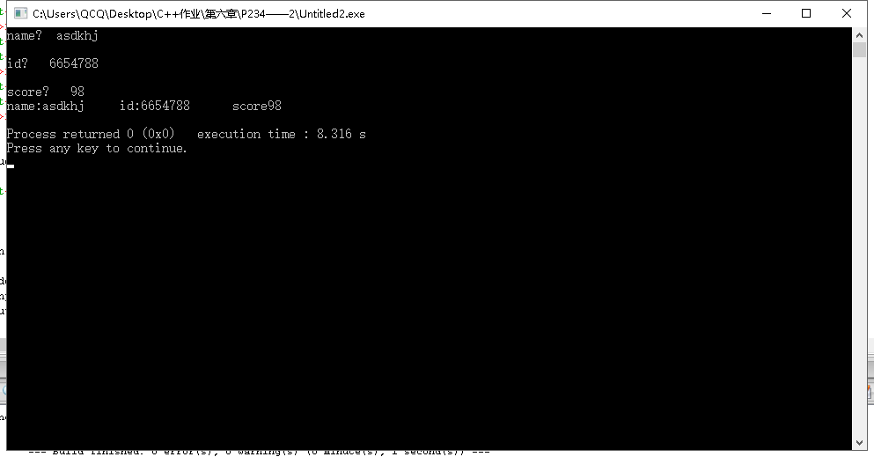

P242_1

#include<iostream>

#include<cstring>

using namespace std;

class Book

{

private:

float price;

int number;

public:

char bookname[6];

void Set(float b,int c);

void display();

void borrow();

void restore();

};

void Book::display()

{

cout<<"书名："<<bookname<<endl;

cout<<"价格："<<price<<endl;

cout<<"存书数量："<<number<<endl;

}

void Book::borrow()

{

if(number==0) cout<<"没有图书，不可借阅";

number--;

cout<<"借阅成功"<<endl;

display();

}

void Book::restore()

{

number++;

cout<<"存书成功"<<endl;

display();

}

void Book::Set(float b,int c)

{

price=b;

number=c;

}

int main()

{

Book book_1;

strcpy(book_1.bookname,"sadff");

book_1.Set(32.5,3);

book_1.display();

book_1.borrow();

book_1.restore();

}

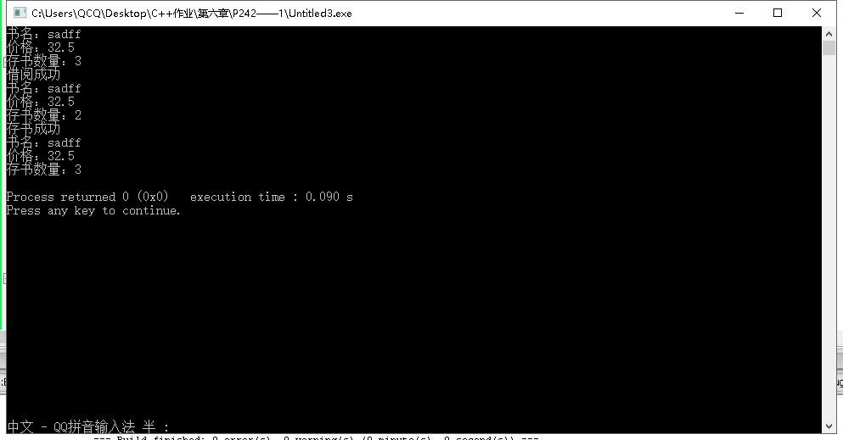

P242——3

#include<iostream>

using namespace std;

class student

{

public:

void scoretotalcount(double s)

{

score = s;

total += score;

count++;

}

static double sum()

{

return total;

}

static double average()

{

return total / count;

}

private:

double score;

static double total;

static int count;

};

double student::total = 0;

int student::count = 0;

int main()

{

double s;

int n ;

student stu;

cout << "请输入学生人数（n)" << endl;

cin >> n;

for (int i = 1;i <= n;i++)

{

cout << "请输入第" << i << "名同学成绩" << endl;

cin >> s;

stu.scoretotalcount(s);

}

cout << "总分：" << stu.sum ()<< endl;

cout << "平均分：" << stu.average() << endl;

}

